From The Addison county Independent, August 24, 2023 – John Flowers

Balint talks mental health with CSAC
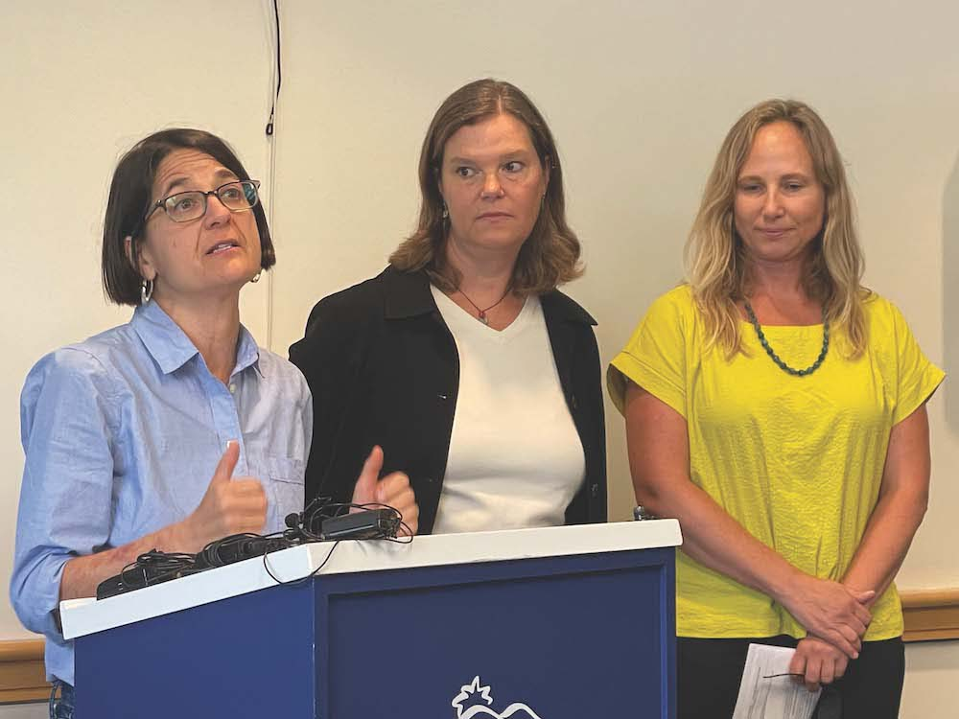
U.S. REP. BECCA Balint, D-Vt., was in Addison County on Aug. 17 to survey flood damage and learn more about our area’s efforts to help people facing mental health challenges. Pictured here, left to right, are Balint, state Sen. Ruth Hardy, D-Middlebury, and Counseling Service of Addison County Executive Director Rachel Lee Cummings. Independent photo/John Flowers

MIDDLEBURY — U.S. Rep. Becca Balint, D-Vt., toured Addison County late last week to survey two kinds of hardships from which many area residents are trying to recover — those caused by recent flooding, and those caused by mental illness.
Balint, the state’s first-term congressperson, spent part of Thursday, Aug. 17, inspecting a variety of sinkholes, collapsed culverts and crater-filled roads in Middlebury, Ripton and beyond.
The other part of her day she spent consulting with Counseling Service of Addison County leaders and stakeholders to see how the federal government might help CSAC better serve those struggling with mental health challenges that have only intensified in the wake of the COVID-19 pandemic and recent flooding.
“We had a mental health crisis before the pandemic, and we are continuing to have a mental health crisis — not just across the state, but across the nation,” Balint told a group of mental health advocates, state officials and local lawmakers who had assembled at CSAC’s Catamount Lane offices.
State officials at the gathering grimly referenced statistics showing a recent, marked climb in suicide deaths in the state.
According to the Vermont Department of Mental Health (DMH), the state recorded an all-time-high of 142 suicides in 2021, up from 117 in 2020 and 109 in 2019. The state has yet to supply numbers for 2022. The years in question coincide with the pandemic and extreme weather events.
Balint promised to work with Congressional colleagues to “make more robust systems of mental health support” following national disasters like pandemics, wildfires or flooding.
As a longtime advocate for a single-payer healthcare system, Balint added she favors a more “holistic” approach to mental health and health care in general.
“The body doesn’t end at the neck,” she said. “‘Health care’ also means ‘mental health care.’”

NEW APPROACHES
Balint said she sympathizes with hospitals that must occasionally lodge mental health patients in their emergency departments, but said “that’s part of dealing with the holistic part of health support. It is a culture shift.”
It’s a shift that’s seen CSAC think outside of the box in helping folks deal with mental health challenges, and its efforts are getting recognized. For example, CSAC officials were pleased to learn that its new “Interlude Program” is already being hailed as a success and could be replicated in other parts of the state.
Interlude’s mission is to help people sort out their mental health challenges in a casual, home-like setting with one-on-one counseling — as opposed to in a hospital or institutional environment. Recently profiled by the Independent, Interlude is based in leased space in Middlebury’s Marble Works complex.
Rep. Jubilee McGill, D-Bridport, and Vermont Mental Health Commissioner Emily Hawes — also present at the Aug. 17 gathering — pronounced themselves big fans of Interlude and said the program warrants a wider use.
McGill is also property manager and coordinator of rental housing for Vergennes-based John Graham Housing & Services, and her clients have included folks dealing with mental health issues.
“The ‘traditional’ model has really been causing harm, and a lot of people are opting not to seek treatment because there’s a lot of trauma there,” said McGill, who praised the Interlude model of “meeting (patients) where they’re at.”
She promised to support efforts to expand Interlude.
“We need to start treating the whole person,” McGill said. “Rather than funneling people into a system, we need to make the system fit them.”
Hawes said she likes the idea of pairing Interlude with other mental health offerings.
“It couples nicely with a couple of other initiatives the state has been working on with our designated agencies, such as our mobile crisis response — which gets out to the communities 24/7 — and ‘988,’ which is the crisis phone number for folks to call,” she said, adding, “You don’t have to be in a crisis to call that number.”
Typically, mobile crisis response services are delivered by a “multidisciplinary two-person team” in the setting where the individual is experiencing a crisis — such as a home or school, according to the DMH’s definition.

NEEDS DISCUSSED
The Independent asked advocates present at the Aug. 17 meeting to identify some of the most pressing needs in their mission to help constituents deal with mental health challenges.
The message — from CSAC Executive Director Rachel Lee Cummings, state Sen. Ruth Hardy, D-Middlebury, and McGill — was that more financial resources are needed to cover surging health insurance premium costs, to provide more affordable housing and to pursue a more aggressive plan for attacking substance use disorder.
“Vermonters are suffering,” Cummings said.
“Housing is really health care,” McGill added. “We need resources for people to remain permanently housed.”
Hardy reiterated her call for a “nationwide system of health care that provides physical, mental and dental health for everyone.”
In the meantime, she praised Addison County health care providers for doing “cutting edge work, that’s collaborative.”
Cummings also stressed CSAC’s need to fill a growing number of staff vacancies. The agency currently has 40 open positions — around half of which are in developmental services and the other half in mental health.
In spite of being short-staffed, CSAC is taking steps to become more responsive to community needs, according to Cummings. She signaled the start of a new program through which a crisis case manager will meet with, and support, children in crisis — wherever they are. It’s the same principle as the Interlude program for adults.
“The idea is to not yank kids out of their location, but to go where they’re at,” Cummings said. “We’re trying to see if we can create another option for people (other than) the emergency department.”

Reporter John Flowers is at johnf@addisonindependent.com.

